Please Read Carefully!!!!

You are on your honor to not cheat during your exam. Cheating means not following the requirements of the take-home exam in any way!

- Copying or pasting any information in any way from any source into your test. This includes but is not limited to copying/pasting rom other documents or spreadsheets, whether written by yourself or anyone else.
- Asking anyone else to assist you by whatever means available while you take the exam. You CANNOT work with anyone during the exam.
- You may not copy/share/text any portion of the exam to another student.

If there is any information or evidence that you have cheated during this exam, the exam will be declared invalid/you will receive a zero on the exam and will not be able to makeup the points in any way!

Please sign here that you have read the above statements and that you adhered to all of the above statements while completing the exam:

1. Completely describe how you would make the following: show calculations and write the explanation of the process to make the solution:

A. (0.5 pt) 10x PBS (phosphate buffered saline) 1.5 liters at pH 7.2
This is the 10x PBS recipe:
0.0270M Sodium Phosphate Monobasic (m.wt. 138.0)
0.0710 M Sodium Phosphate Dibasic (m.wt. 142.1)
1.500 M Sodium Chloride (m.wt. 58.44)

B. (0.5 pts) 50 mL’s of an 8.0% gelatin solution in 1x PBS using the 10x PBS you made in step A.

2. (1 pt) You are doing a colorimetric protein assay to determine the protein content of an unknown sample. You are starting with 10mM standard and perform the following protocol to establish the standard curve. Fill in the table for concentration of standard in each well. Also, generate your standard curve using Excel, which should include the R^2 value and the trendline equation. Use this information to determine the concentration of your unknown based upon its absorbance. Include the graph and your calculations in your answers. Also be sure that you label your x and y axis correctly. Also indicate whether the R-square value is “good” in the below data, and what is acceptable?

μl H20 | μl standard | mM Standard | Absorbance
100 | 0 | 0 | 0
95 | 5 |  | 0.15
90 | 10 |  | 0.22
80 | 20 |  | 0.38
60 | 40 |  | 0.76
20 | 80 |  | 1.25
0 | 100 | 10 | 1.50
Unknown  μl H20 | μl unknown
50 | 50 |  | 0.67

3. A. (1pts) Explain in detail how monoclonal and polyclonal antibodies are generated. Also explain what the difference is between a monoclonal and polyclonal antibody.

4. (1 pts) Show in pictures what the following means (I want to see your art!):
A. Horse α dog α mouse α HSA (HSA=Human serum albumin) α=Αnti

5. (1 pts) What are 3 differences and 3 similarities between a Western Blot and an ELISA?

6. (1 pts) Explain the purpose of bacterial transformation and give an example of a biomedical product derived from bacterial transformation.

7) (1 pt) - Using the protocol in the lab manual with rpARA plasmid, give two reasons why the following results might have happened

Plate | - Plasmid | + plasmid
LB | Growth | Growth
LB+AMP | No growth | 100 white colonies
LB+AMP+ARA | No growth | 100 white colonies

- Reason 1:

- Reason 2:

Using the protocol in the lab manual with rpARA plasmid, give two reasons why the following results might have happened (4)

Plate | - Plasmid | + plasmid
LB | Growth | Growth
LB+AMP | No growth | No growth
LB+AMP+ARA | No growth | No growth

- Reason 1:

- Reason 2:

8. (1 pts) You start with a 1:100 dilution of antibody in wells of Column #1. You serially dilute across a microtiter plate. What is the dilution factor in column 12? Also indicate what volumes you would start with in every well if you want to end with 100μl final volume in every well.

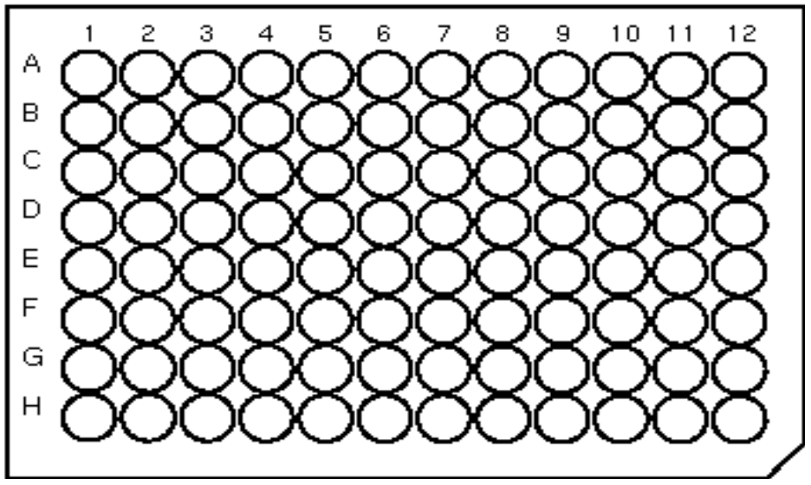

9. Express each of the following as a dilution, using a / mark and the number 1 as the numerator (for example, 1/2)… (0.2 pt each)

- 2 ml of original sample + 98 ml of water

b. 0.5 ml of sample diluted up to 10 ml

c. 1 part solute : 20 Parts solvent

d. 10mL solute in 90mL solvent

e. 1 :1000

10. (1 pt) Explain in detail the entire process of a gram stain. What are the four major liquids that are used and what do they do? What does crystal violet bind to? Why do gram positive bacteria stain a dark purple while gram negative bacteria stain pink? Also, give an example of a type of gram positive bacteria and a type of gram negative bacteria.

